Functional Requirements for Personalized

Customer Service

**CUSTOMER DOMAIN:**

1.**User Registration :**

* Allow users to create accounts through their personal information such as name, email, password, phone number etc.
* Secure login and user profile management.
* Only accessed user will be having authority to login to the website.

2.**Category search**

* Allow users to select for categories like bike, scooter etc.
* Once the category is been selected then user should go for selecting the particular model and also the color.
* After the selecting process , the page will be directed to the service page.

**4.Contact Us :**

* In case of any query and clarification user can contact with Customer Support section using admin’s mail id .

**5.About Us**

* It contains description of our website and the services available for the customer that one can opt .

3. **Service and Maintenance:**

* This page will provide some tips for the customer about the model and maintenance of the particular vehicle.
* Maintenance page will contain the instance of services and also different types of services which the customer can check and opt for his vehicle according to the type of instance.
* Each and every action of customer in the maintenance page will be maintained and will be directed to admin dashboard.
* Whenever the customer opts for any of the service ,then the service charge will be applied.
* It is not necessary for the customer to opt all the services available at the time.

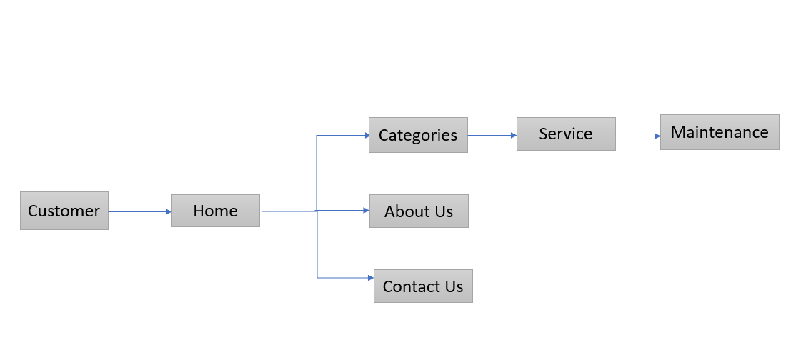

* customer home categories service maintenance

**ADMIN**

**1**.**Admin Login:**

* Allows the admin to login to the dashboard using appropriate email and password.

**2.Admin’s Access:**

* Admin can have the access to add and delete the models of bike or scooter.
* Admin can trace the customer details, when the user registration is been made the personal information entered by customer will be accessible to admin and can verify the customer details.
* Admin can check the list of customer who will be having the upcoming services on the particular month.
* If any customer skips any instance of services then admin will be notified.
* Completion or On progress of services of particular customer’s model will also be notified to admin.

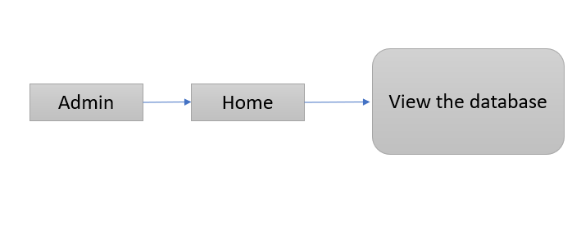

* **admin home view the database**